**New Patient Registration/Health Questionnaire**

**To register with the Practice please complete this questionnaire as fully as possible. The information will help the doctor to make an initial assessment of your health which will help in your future treatment.**

**Please bring this with you when you attend your new patient check.**

|  |  |  |  |
| --- | --- | --- | --- |
| Surname |  | Forename(s) |  |
| Date of Birth |  | Marital status |  |
| Address |  |  |  |
|  | | Postcode |  |
| Home Number |  | Mobile |  |
| If you have supplied your mobile number, please confirm if you would be happy to receive contact from the surgery via text i.e appointment reminders | |  | Yes / No |
| Email address |  |  |  |
| Occupation |  |  |  |
| Weight (approx) |  | Height |  |
| Date of completion of this form | |  |  |

# Smoking

|  |  |  |  |  |  |
| --- | --- | --- | --- | --- | --- |
| Do you smoke? | | Yes / No | **If yes, how many?** | | |
| Cigarettes per day |  | Cigars per day |  | Ounces of tobacco per day |  |
| How old were you when you started smoking? | | | |  | |

## Ex-Smokers

|  |  |
| --- | --- |
| How old were you when you stopped smoking? | How much did you smoke per day? |
|  |  |

## Passive Smoking

|  |  |  |  |
| --- | --- | --- | --- |
| Are you exposed to smoke at work? | Yes / No | At home? | Yes / No |

# Alcohol

For the following questions please circle the answer which best applies. 1 Unit = 1/2 pint of beer or one glass of wine or 1 single spirit.

|  |  |  |  |  |  |
| --- | --- | --- | --- | --- | --- |
| How often do you have a drink containing alcohol? | *Never* | *Monthly or less* | *2-4 times per month* | *2-3 times per week* | *4+ times per week* |
| How many units of alcohol do you drink on a typical day when you are drinking? | *1-2* | *3-4* | *5-6* | *7-9* | *10+* |
| **Men**: How often do you have **eight** or more drinks on one occasion? | *Never* | *Less than monthly* | *Monthly* | *Weekly* | *Daily or almost*  *Daily* |
| **Women**: How often do you have **six** or more drinks on one occasion? |
| How often during the last year have you found that you were not able to stop drinking once you had started? | *Never* | *Less than monthly* | *Monthly* | *Weekly* | *Daily or almost*  *Daily* |
| How often during the last year have you failed to do what was normally expected from you because of drinking? | *Never* | *Less than monthly* | *Monthly* | *Weekly* | *Daily or almost*  *Daily* |
| How often during the last year have you needed an alcoholic drink in the morning to get yourself going after a heavy drinking session? | *Never* | *Less than monthly* | *Monthly* | *Weekly* | *Daily or almost*  *Daily* |
| How often during the last year have you had a feeling of guilt or remorse after drinking? | *Never* | *Less than monthly* | *Monthly* | *Weekly* | *Daily or almost*  *Daily* |
| How often during the last year have you been unable to remember what happened the night before because you had been drinking? | *Never* | *Less than monthly* | *Monthly* | *Weekly* | *Daily or almost*  *Daily* |
| Have you or somebody else been injured as a result of your drinking? | *No* | *Yes, but not in the last year* | | *Yes, during the last year* | |
| In the last year has a relative or friend, or a doctor or other health worker been concerned about your drinking or suggested you cut down? | *No* | *Yes, but not in the last year* | | *Yes, during the last year* | |

# ETHNICITY & LANGUAGE QUESTIONNAIRE

This short questionnaire will give surgery staff some basic information about your communication support needs and ethnicity, to support your health care.

We would be grateful if you could complete **one form for each family member** joining the Practice

**NAME**  **DOB**

|  |
| --- |
|  |

What is your main language?

**WHAT IS YOUR ETHNIC GROUP?**

Do you need an interpreter or sign language support? **Yes**  **No**

Choose **ONE** section from A to F then tick **ONE** box which **best describes** your ethnic group or background

|  |  |  |  |  |
| --- | --- | --- | --- | --- |
| **A. White** | |  | **B. Mixed or multiple ethnic groups** | |
| British |  | Any mixed or multiple ethnic group |  |
| Irish |  |  | |
| Polish |  | **D. African** | |
| **Any other white ethnic group, please specify below:** | | African, African British |  |
|  | | **Other African, please specify:** | |
|  | |  | |
| **C. Asian, Asian British** | |  | |
| Pakistani, or Pakistani British |  | **E. Caribbean or Black** | |
| Indian, Indian British |  | Caribbean, Caribbean British |  |
| Bangladeshi, Bangladeshi British |  | Black, Black British |  |
| Chinese, Chinese British |  | **Other Caribbean or Black, please specify:** | |
| **Other Asian, please specify:** | |  | |
|  | |  | |
|  | | **Other, please specify:** | |
| **If you would prefer not to provide this information, please tick here:** |  |  | |

**FOR OFFICE USE:**

|  |  |
| --- | --- |
| Reg details to computer |  |
| NHS no |  |
| Scanned |  |
| Sent to H/V S/N service |  |

## Diet

|  |  |
| --- | --- |
| Do you add salt to your food after cooking? | Yes / No |
| Do you have a varied diet including milk, meat, vegetables and fruit? | Yes / No |
| Has your Cholesterol been checked in the last 2 years? | Yes / No |

## Exercise

|  |  |
| --- | --- |
| Do you take regular exercise? | Yes / No |
| If yes, what sort of exercise? |  |
| How many times per week? |  |

## Family History

|  |  |  |
| --- | --- | --- |
| Heart Disease (heart attacks, angina) | Yes / No | Which family member? |
| Stroke? | Yes / No | Which family member? |
| Cancer? | Yes / No Site of cancer? | Which family member? |

## Allergies

|  |  |
| --- | --- |
| Are you allergic to any substances or foods? | Yes / No |
| If yes, please give details: |  |

## Medication

Please give details of any medication which you take (prescribed or otherwise).

|  |  |  |
| --- | --- | --- |
|  | Name of drug | Dosage |
| 1 |  |  |
| 2 |  |  |
| 3 |  |  |

## Past Medical History

|  |
| --- |
| Please give details of any hospital treatment as an in-patient: |
|  |
| Please give details of any treatment for any chronic medical conditions: |
|  |
| Please give dates of any X-ray, MRI or CT scans, Mammogram, Ultrasound: |
|  |

## Immunisations

|  |  |
| --- | --- |
| Dates of Triple/polio/HIB: |  |
| Dates of MMR: |  |
| Date of last Tetanus: |  |

## Female Patients

|  |  |
| --- | --- |
| Date of most recent cervical smear: |  |
| Result of most recent smear: |  |
| Please give details of any complications in pregnancy: |  |

## Carers

|  |  |
| --- | --- |
| Do you need / have anyone who looks after you or your daily needs as Carer? | Yes / No |
| If “Yes”, would you like them to deal with your health affairs here? | Yes / No |
| Do you care for anyone else?  If “Yes”, ask the receptionist about the ways we can help. | Yes / No |

|  |  |
| --- | --- |
| **Date form completed** |  |
| **Signature** |  |

**The following pages are related to access to your medical records. Please read the information provided, and complete the opt out forms if necessary.**

**Summary Care Records – Your Emergency Care Summary**

The NHS in England is introducing the Summary Care Record, which will be used in emergency care.

The record will contain information about any medicines you are taking, allergies you suffer from and any bad reactions to medicines you have had to ensure those caring for you have enough information to treat you safely.

Your Summary Care Record will be available to authorised healthcare staff providing your care anywhere in England, but they will ask your permission before they look at it. This means that if you have an accident or become ill, healthcare staff treating you will have immediate access to important information about your health.

Your GP practice is supporting Summary Care Records and as a patient you have a choice:

* **Yes I would like a Summary Care Record** – you do not need to do anything and a Summary Care Record will be created for you.

* **No I do not want a Summary Care Record** – **Please complete the form on the next page.**

If you need more time to make your choice you should let your GP Practice know.

For more information talk to our Patient Advice and Liaison Service (PALS) (01539 795497 – Westmorland General Hospital / 01228 814008 – Cumberland Infirmary)**,** GP practice staff, visit the website (www.cumbriaccg.nhs.uk) or **www.nhscarerecords.nhs.uk** or telephone the dedicated NHS Summary Care Record Information Line on 0300 123 3020.

Additional copies of the opt out form can be collected from the GP practice, printed from the website **www.nhscarerecords.nhs.uk** or requested from the dedicated NHS Summary Care Record Information Line on 0300 123 3020.

**You can choose not to have a Summary Care Record and you can change your mind at any time by informing your GP practice.**

If you do nothing we will assume that you are happy with these changes and create a Summary Care Record for you. Children under 16 will automatically have a Summary Care Record created for them unless their parent or guardian chooses to opt them out. If you are the parent or guardian of a child under 16 and feel that they are old enough to understand, then you should make this information available to them.

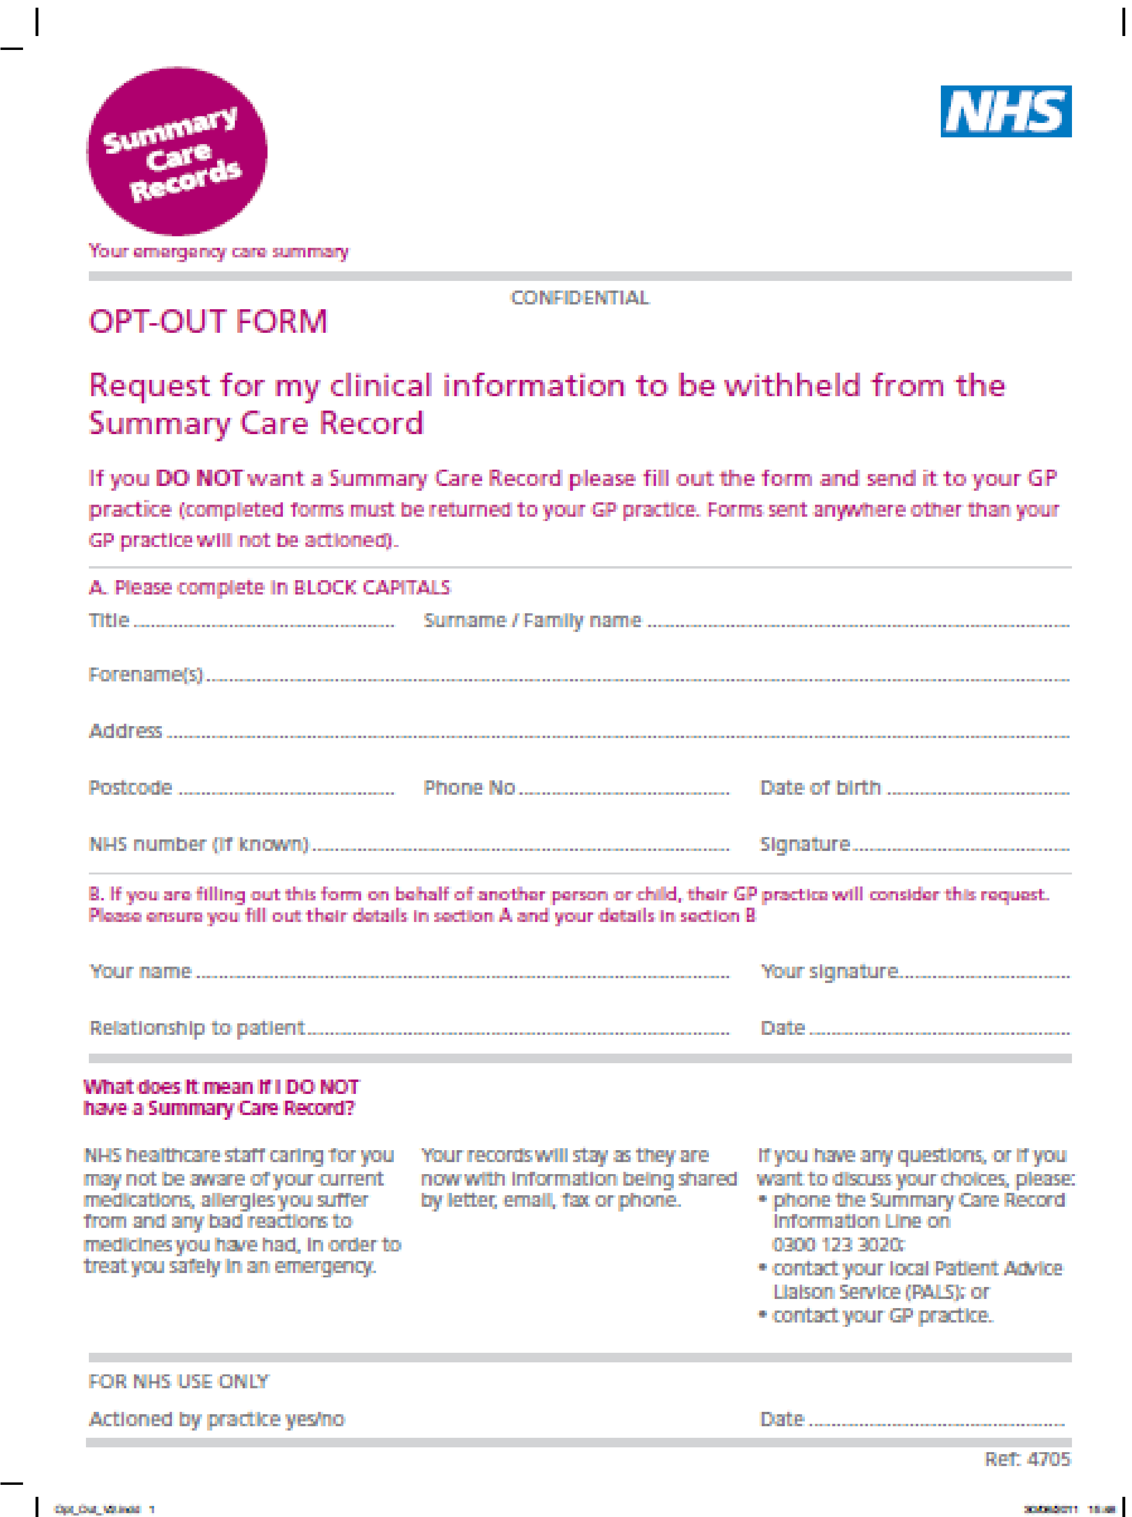

## HSCIC care.data Opt-out Form

**(From secondary use of patient identifiable data)**

Dear Doctor

Please could you add the relevant ‘electronic flags’ to my medical records and the records of those for whom I am responsible (if applicable), in order to ensure that:

☐ Personal confidential information is **not uploaded from my/our GP records** to the **Health and Social Care Information Centre (HSCIC)** via the General Practice Extraction Service (GPES) or other means.

### (9Nu0 – Dissent from secondary use of GP patient identifiable data)

and/or

☐ My/our personal confidential information gathered from ***any* health and social care setting** is **prevented from leaving** the HSCIC.

### (9Nu4 - Dissent from disclosure of personal confidential data by Health and Social Care Information Centre)

I understand the implications of this request:

* that it will not affect the medical care that I/we receive either from the GP surgery or from anywhere within the NHS or the private sector

* that this refusal does not in any way prohibit the GP surgery from sharing my/our medical information with other NHS and private services, where necessary, to provide effective clinical care

▪ that I/we can change our mind at any time about this refusal

* that I/we will inform you if I/we subsequently decide to opt back into this system

|  |  |  |  |
| --- | --- | --- | --- |
|  | **Please complete in BLOCK CAPITALS** | | |
| Surname |  | Forename(s) |  |
| Date of Birth |  | Phone Number |  |
| Address |  | | Postcode |
| Signature |  | | Date |

|  |  |  |  |
| --- | --- | --- | --- |
| **ADDITIONAL PATIENT DETAILS (Please complete in BLOCK CAPITALS)**    **Please record my dissent on behalf of the following patients:** | | | |
| Surname |  | Forename(s) |  |
| Date of Birth |  | Phone Number |  |
| Address |  | | Postcode |

|  |  |  |  |
| --- | --- | --- | --- |
| Surname |  | Forename(s) |  |
| Date of Birth |  | Phone Number |  |
| Address |  | | Postcode |

|  |  |  |  |
| --- | --- | --- | --- |
| Surname |  | Forename(s) |  |
| Date of Birth |  | Phone Number |  |
| Address |  | | Postcode |

|  |  |  |  |
| --- | --- | --- | --- |
| Surname |  | Forename(s) |  |
| Date of Birth |  | Phone Number |  |
| Address |  | | Postcode |

If you are completing this form on behalf of a child please ensure you fill out their details above and include your details below.

|  |  |
| --- | --- |
| Your Name |  |
| Your Signature |  |
| Relationship to the Patient named above |  |
| Date |  |

***Thank you for completing this questionnaire.***